Ovid Fasti Book 2 XVIII

Introduction

Arion was a famous lyric poet who came from Corinth, but made his fortune in Italy and Sicily. This story about his return to Greece is told by Herodotus in Book 1, chapter 24 of his Histories. Arion could even charm animals with the beauty of his music and song. After winning fame and fortune in Sicily and Italy, he boards a ship to return home to Corinth. He is attacked by the crew, who covet his wealth. He begs to be allowed to play a last tune, puts on a garland and leaps overboard. A passing dolphin is said to have rescued him.

Quod mare non novit, quae nescit Ariona tellus?
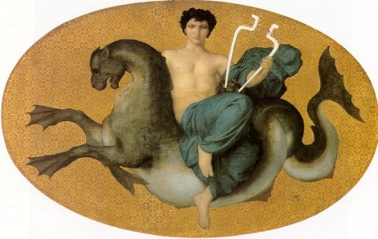
carmine currentes ille tenebat aquas
saepe sequens agnam lupus est hac voce retentus;
saepe avidum fugiens restitit agna lupum.
Nomen Arionum Siculas impleverat urbes;
captaque erat lyricis Ausonis ora sonis
inde domum repetens puppim conscendit Arion
atque ita quaesitas arte ferebat opes.

What sea does not know, what land does not know Arion?
By his song he used to hold back the running waters.
Often the wolf, while pursuing the lamb is held back by his voice;
Often the lamb hesitated while fleeing the greedy wolf.
The fame of Arion had filled Sicilian cities
and by the music of his lyre , he had charmed the Ausonion land.
Thence winding homewards Arion boarded a ship
and thus carried (with him) the acquired riches (won) by his art.

Glossary:
1. Ariona: Greek accusative of Arion.
Nescio –ire – ivi – itum: not know
Mare – is: sea
Tellus- telluris: land, earth, country

2. Carmen –inis: song, tune, verse
Ille – a – ud: he, that
Teneo – ere – ui: hold
Aqua – ae: water
3. saepe: often
Lupus –i: wolf
Sequens: following
Agna – ae: ewe lamb (You are probably more used to seeing ‘agnus’ as in ‘agnus Dei’: the lamb of God. ‘Agna’ just means a female lamb.)
Retentus: ppp of retineo – inere, -inui, -entum: to hold back or restrain

4. avidus: greedy, eager, hungry
Fugiens (fugio): fleeing
Restito – are: hesitate, stay behind
Implere: fill

5. Arionium: adjectivalhere.
Siculas... urbes: 'Sicilian cities'.

6. capta (capere): captivate or charm
Lyricus: of the lyre
Ora –ae: land, country, coast
7. inde: from there, thence
domum: Arion was returning home to Corinth from Italy and Sicily.
repetens: 'making for home again'.
Puppis –is: ship
Conscendo – ere, - endi, -ensum: to embark, board a ship
Atque: and (then)
Ita: thus
Fero (ferre, tuli, latum): to carry, carry off
Quaesitae opes: acquired riches

